Parameters and Hyperparameters

- There are parameters and hyperparameters
- Parameters are all internal to the model
  - Data specific
  - Part of the model
  - With ANN weights and biases
  - Regression coefficients
- Hyperparameters are external to the model
  - They need to be tuned / chosen
  - Can be judgement based or found through algorithms
  - 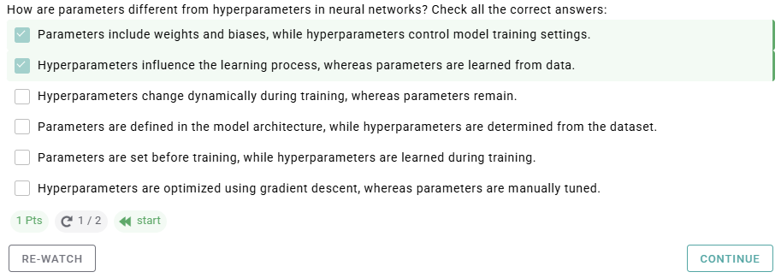
  - Examples
    - Related to architecture
      - Number of layers
      - Number of neurons
      - Dropout function
      - Activation function
    - Related to training
      - Objective function
      - Learning rate
      - Batch size
      - Weights initialization
      - Optimization algorithm
      - Number of epochs
  - 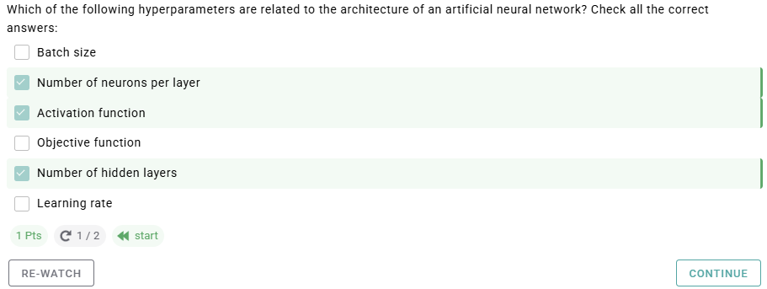

Related to Architecture

- Number of Hidden Layers
  - Chosen before
  - What if too few?
    - Underfitting
  - What if too many?
    - Overfitting
    - Reduce overfitting by regularization, by adding a penalty term
  - For many problems, start with 1-2 hidden layers
  - For more complex problems gradually increase number of hidden layers, until overfitting
  - 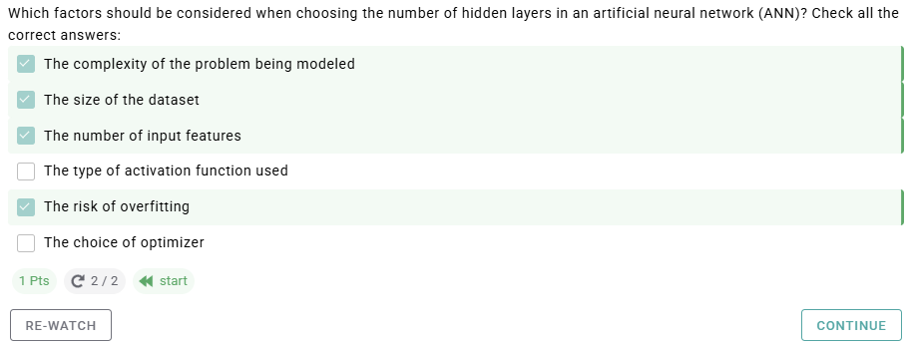
- Number of Hidden Neurons
  - Should be
    - Between the size of input layer and the size of the output layer
    - About 2/3 size of input layer plus output layer
    - Less than twice the size of input layer
  - Often the number of neurons decrease ith each layer, like a pyramid
  - Increase the number of neurons gradually until the network starts over-fitting
  - Early stopping
    - Choose more layers and neurons and use early stopping to prevent it from over-fitting. Stop training when the network starts training on small local features, and the loss increases.
- Dropout rate
  - Regularization tool
  - Helps avoid overfitting
  - Randomly turning off a portion of neurons at every training iteration
  - Tuning
    - Drop 20 % – 50 %, starting with 20%
      - Too low Almost no effect
      - Too high Under-learning
    - Use a larger network
      - Network learns more from independent representations
  - 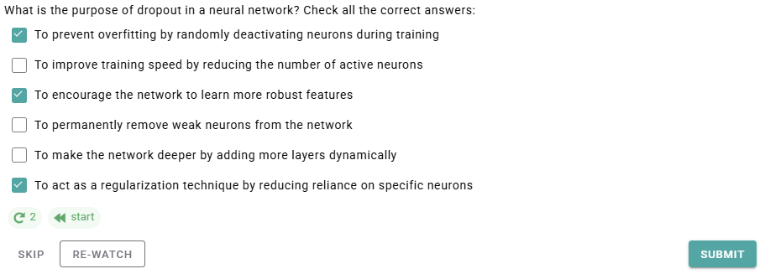
  - 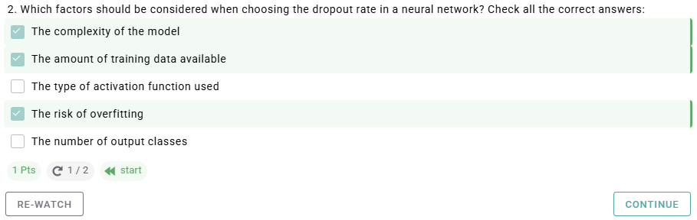
- Activation Function
  - Introduce non-linearity
  - They allow neural networks to learn nonlinear patterns and prediction boundaries
  - Types
    - Sigmoidd
    - Tanh
    - Step Function
    - Softplus
    - ReLU
    - Softsign
    - Elu
  - Step function is used in the perceptron
  - ReLU is currently most popular
  - Sigmoid is used for binary output (esp probability)
  - Softmax is used for multi-class categorical prediction
  - 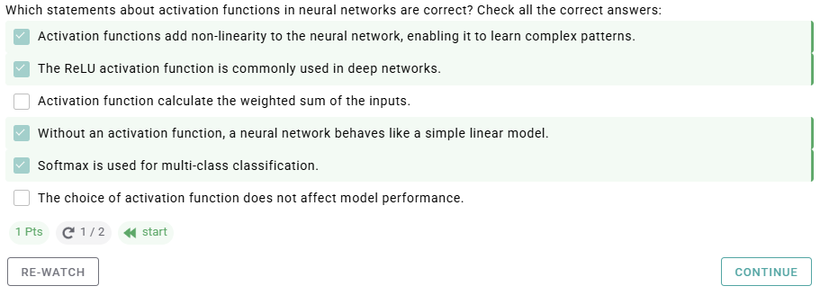

Related to Training

- Which
  - Learning Rate
  - Batch size
  - Weights initialization
  - Number of epochs
- Learning rate
  - How quickly the gradience descent algorithm updates parameter estimates – weights and biases
  - Low learning rate slow learning, smooth convergence.
    - Slow
  - High learning rate aggressive learning, but may not converge.
    - Erratic
  - Optimal learning rate is often about half of the maximum learning rate
    - Maximum rate at which the algo still converges
    - Optimal learning rate is decaying as the gradient approaches 0.
      - Thus the learning rate is not constant across the training
      - Can start with a high learning rate that makes the gradient descent algorithm diverge
      - Divide by 3 and try again, until training converges
    - 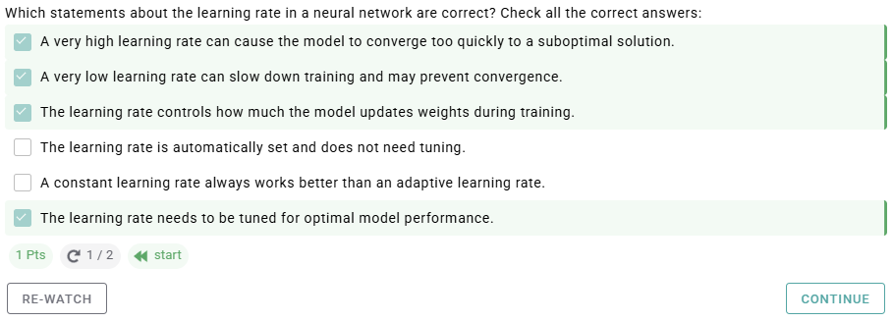
- Number of epochs
  - Vas ist?
    - Cycles that use the entire dataset in each cycle.
    - Number of epochs is the number of times all the training data are used.
    - Increase the number of epochs until prediction performance starts decreasing even if the training accuracy is still increasing
    - Very large number of epochs causes overfitting
    - 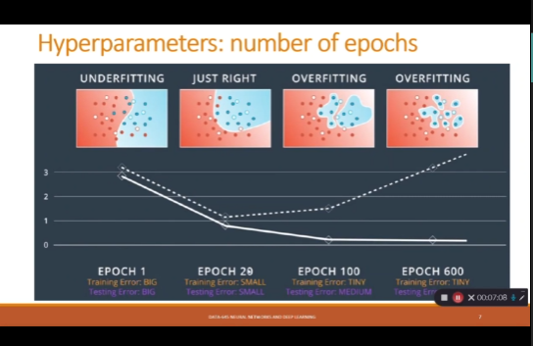
  - Rules of Thumb
    - 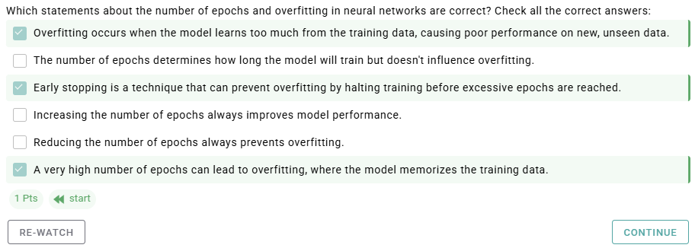
- Mini-batch size
  - Subsamples we are using at each iteration of training (gradient descent)
  - Smaller batches allow for fast iterations
  - A good default for batch size might be 32
    - 64, 128, 256
- Weight initialization
  - Need to start somewhere
  - Zero initialization – set all weights to zero
  - Random initialization is to have a random initialization
  - 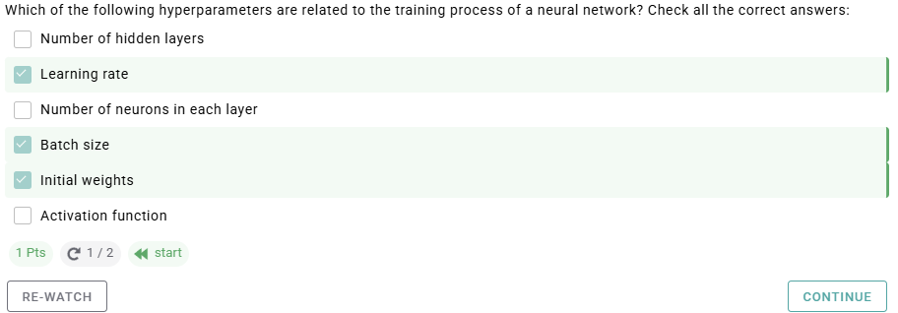

Tuning

- Types
  - Grid Search
  - Random Search
  - Gradient-based optimization
  - Bayesian optimization
- Grid Search
  - Draw a grid of possible combinations of hyperparameters and compare performance for a given Deep Learning algorithm
  - Grid search is the simplest algo for tuning
  - Fitting, training, and evaluating a neural network for every combination of hyperparameters on a grid is long and expensive
  - Also, it is limited to a chosen set of values, which may exclude the optimal hyperparameters
- Random Search
  - Randomly choose combinations of hyperparameters from the searchable space of possible combinations
  - Random search either uses fewer points than the grid search, or covers more levels of each hyperparameters
  - In the first case, it is less expensive that the grid method
  - In the second case, it covers more hyperparameter values
  - It has an option of early stopping
- Gradient-based optimization
  - A methodology to optimize several hyperparameters, based on the computation of the gradient of the objective function with respect to the hyperparameters
    - Compute the hyperparameter gradients of the loss
    - Update hyperparameters via gradient descent
  - More efficient than the grid search and the random search.
  - However, hypergradients may be complex. And some hyperparameters are not differentiable (batch size, architecture choices).
- Bayesian optimization
  - Replace a purely random search with a guided search that uses the previously obtained knowledge to help narrow down the search space of good hyperparameter combinations
  - Guided search: Uses information obtained from previous searches to help narrow down the search space of good hyperparameter combinations.
  - Next time, we’ll try hyperparameters closer to the good values.
  - How works
    - Uses probabilistic modeling to establish a posterior distribution of the loss function, informed by previously tested hyperparameter combinations.
    - It iteratively selects new hyperparameters that are expected to enhance performance, finding a good balance between exploration and exploitation.
    - Assigns higher probability to hyperparameters that are likely to lead to good outcomes
- 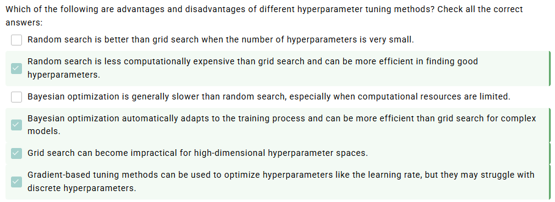

- 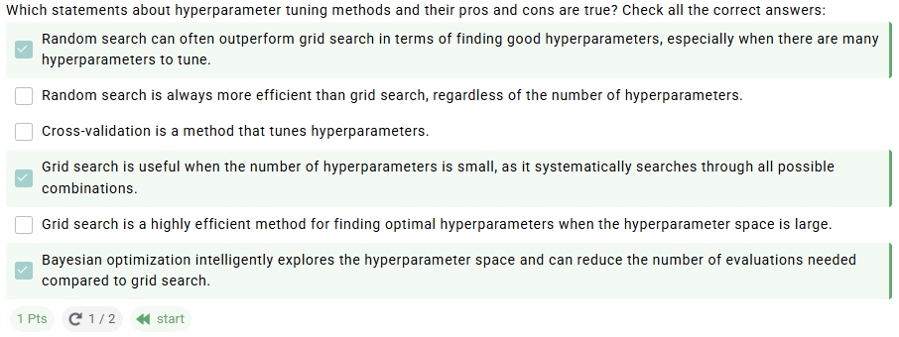

Bayesian Optimization

- Process
  - Start with initial set of hyperparameters
  - Then Bayesian process. Black box problem evaluation
  - Training of gaussian process regressor
  - Calculation of acquisition function
  - Gaussian process models the loss
- Key players
  - Loss functions
    - Measures performance, a given set of hyperparameters
  - Probabilistic surrogate model
    - Approximates the loss function. Usually it is the Gaussian model or Bayesian neural network.
  - Acquisition function
    - Expected improvement
    - Probability of improvement
    - And upper bounds
- Optimization
  - Initialize random sampling
    - Bayesian optimizer starts with a few initial sets of hyperparameters. They are used to train the surrogate model.
  - Iterative optimization
    - At each iteration, the acquisition function is optimized to suggest the next set of hyper parameters to evaluate
  - Surrogate model update
  - Optimizing the acquisition function
    - We find the most likely set
  - Stopping criteria
    - Continue iterations until a stopping criterion is met. We can stope either when we obtain a combination of hyperparameters with satisfactory performance or when we reach the preset maximum number of iterations
- Example
  - Define the Hyperparameter and Loss Function
    - Two initial values are randomly chosen after training the neural network with each learning rate.
  - Fit a Guassian Process Model
    - A set of normal distributions at different hyperparameters then the combination of losses that contribute to this hyperparameter is a multivariate normal distribution.
      - Means
      - Variances
      - Correlations
    - We use th kernel function
      - Can be different forms
      - Square or exponential kernel is one of the most common
      - If two hyperparameter values are close, the correlation is high and weakly correlated for hyperparameters are far from each other.
      - 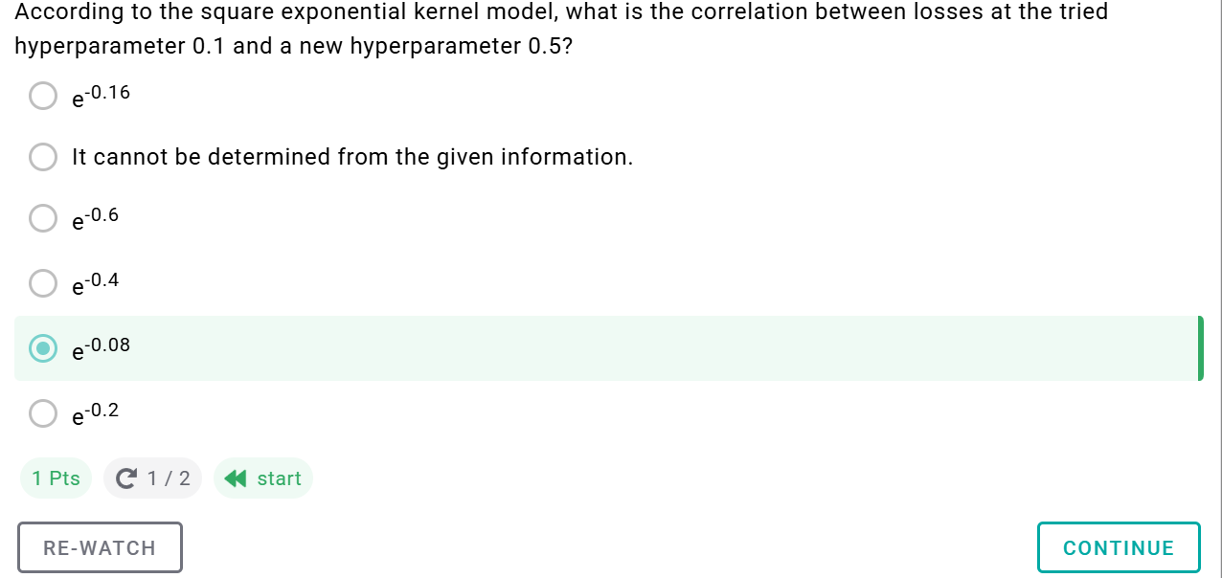
  - Pedict GP for New Hyperparameter Value
- Acquisition Function
  - Guide the selection of the next hyperparameter value
  - An acquisition function guides selection of the next hyperparameter value to evaluate by balancing exploration (sampling in uncertain regions), and exploitation (function on promising areas)
  - Types
    - Expected Improvmenent
      - Improving on the best observed loss
      - Balances exploration and exploitation
    - Probability of Improvement
      - The normal probability of being better than the best observed results so far.
    - Upper Confidence Bound (UCB)
      - Uses a confidence interval to balance exploration and exploitation.
      - The parameter k controls the trade-off
      - Large k more exploration, small k = more exploitation
      - 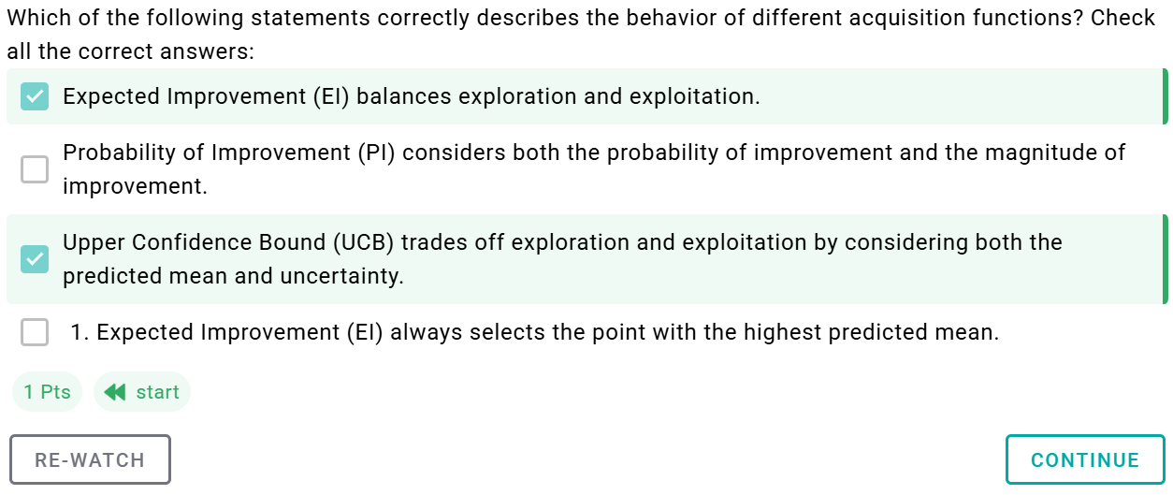
- Overall
  - Bayesian hyperparameter optimization leverages a surrogate model to guide the select of hyperparameters, prioritizing promising regions while reducing unnecessary evaluation of the cost function
  - The approach efficiently navigates the hyperparameter space, making it particularly useful for automated tuning in large search spaces or computationally intensive scenarios.
  - Software languages have libraries for all four hyperparameter tuning methods.

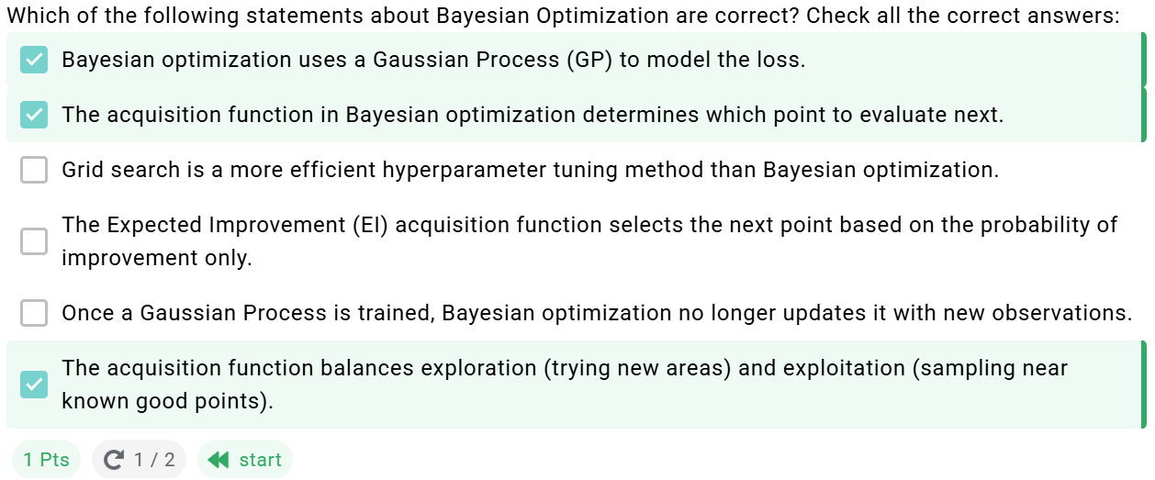

Lecture

Convexity vs Nonconvexity
- Convex
  - If you choose any two points within the “bowl” (assume a quadratic), they will always be above the surface. They will never “escape” the decision space.
- Non-Convex
  - The line between two points can “escape” the surface. Here, the line connecting two points are travels below the surface.

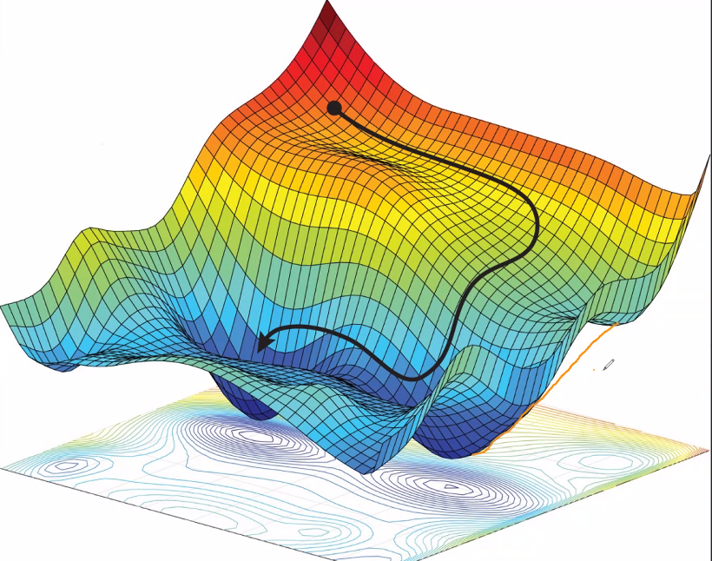

Hyperparameters
- # of Hidden layers are hyperparameters
  - Deep neural networks do not guarantee good accuracy
  - Danger of overfitting (more parameters)
- # of Neurons per Hidden Layer
  - # of neurons in input and output layer is determined by the type of input and output your task requires.
  - For the hidden laye4r, it used to be common practice to size them to form a pyramid
    - But this has fallen from favor
  - You can increase the # of neurons gradually to prevent overfitting
- Learning Rate, Batch Size, Other Hyperparameters
  - Learning rate is arguably the most important hyperparameters
  - Best practice is to start large and decrease.
  - Better optimizer?
- Batch Size
  - Batch size is important. But mostly between 20 and 32.
- Activation
  - In general, ReLU is a good default for hidden layers. For the output layer, depends. Softmax or Sigmoid.

Tuning
- Randomized search
- K-fold cross validation is computationally too expensive.
  - Cannot handle many hyperparameters
- There are good Python libraries
  - 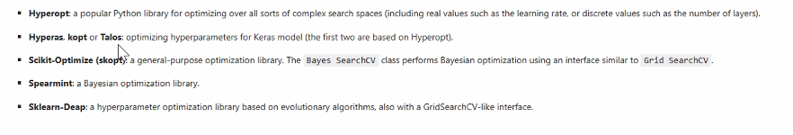
- Finding the right hyperparameters
  - There’s not much of a theoretical foundation
    - Initialization has a theoretical framework
      - So does batch size
    - But mostly it’s tuning and result based
  - Support Vector Machines are similar
    - Its just result based

Reading
- Classic approach
- K-Fold Cross Validation
- Pretrained models for X-ray
  - This might actually work better
  - Google collab.

